Methodology and guidelines for developing competence-based study programmes and monitoring them
Based on the previously defined concept of competence-based education the following sections provide the methodology and guidelines for developing competence-based study programmes in Azerbaijan.

General Methodology
The starting point would be the Tuning development circle with its different steps.

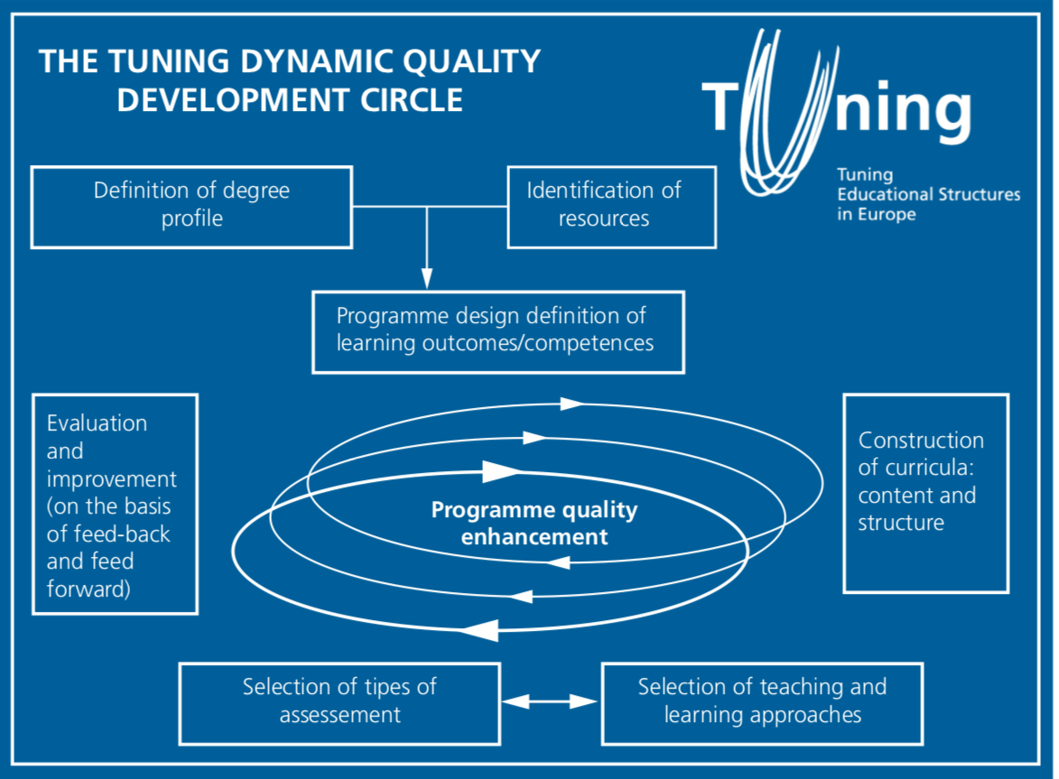
The important questions that have to be answered when designing a study programme (from Tuning methodology):
- Has the social need for the study programme on a regional/national/European level been identified?
- Has this been done on the basis of a consultation of stakeholders: employers, professionals and professional bodies?
- What is the point of view of academics (they should be involved in the design of programmes)?
- Are the necessary resources for the study programme available?
- Are the programmes designed in terms of ECTS-credits based on student workload?
- Are the objectives of the programme described in terms of learning outcomes /competences (knowledge, understanding, skills and abilities) that have to be met.
- Generic and subject specific competences have to be defined
- A translation into the curriculum: content (topics to be covered) and structure (modules and credits) has to be made
- As well as a translation into educational units and activities to achieve the defined learning outcomes.
- The approaches to teaching and learning (types of methods, techniques and formats) have to be specified or renewed, as well as the methods of assessment (when required, the development of teaching material)
- An evaluation system has to be developed to enhance its quality constantly.
There must be a clear balance between the generic competences and subject-related competences.
Generic competences

Be careful: they should highlight the differences between the bachelor level and the master level.
So far, we recommended that the same working group elaborates the generic competences for both levels.

Subject related competences
When a new study programme is created it is relatively easy to describe it in terms of competences because this description is the starting point of the design of the study programme. But when a study programme is already existing, it is necessary to survey the labor market representatives to know if the competences acquired by graduates match with the needs they express.
If the competences required by the labor market do not match the competences acquired by the graduates, the content of the study program should be revised.
It is the case for the study programmes in the IT field.
When formulating the competences associated to a study programme, the level of studies has to be taken into account. The so called “Dublin Descriptors” could be useful:
Cycle | Level description
1st (bachelor) | (includes) some aspects of forefront knowledge (of their field)
2nd (master) | (provides) basis (or opportunity) for originality
3rd (doctoral) | (contributes through) original research (that extends front of knowledge)
Template of a study programme
It should include four parts:
  - A description of the competences (generic and specific ones);
  - A list of jobs or sectors of activities the graduates can apply for;
  - The curriculum;
  - The way of assessment of learning outcomes / competences.

From theory to practice

What documents should be provided?
2 documents should be provided
- One for students, their parents, the employers
  - Rather short (5-6 pages)
    - Example of the Tuning fiche : example of a competence based curriculum in the field of physics (annex 1)
    - The FR experience :
      - The upstream work
        - FR experience PPT doc. (annex 2)
      - An example : the BA fiche for IT (annex 3)
    - Example of the Latvian bachelor and master study programme for IT
(annex 4)
  - These documents should be the first part of the Diploma Supplement (the second part is the transcript of records with ECTS)
- One for academic staff :
  - It is a complete document with the detailed content of the programme for each year of study, each semester, the lecture hours, the hours of practical work, the training periods, the total number of hours, the teaching staff (academic, professional), how competences are assessed, the different pathways, etc.
We would like to emphasis that the Diploma Supplement has to be delivered free of charge to each graduate in a widely spoken language.
In order to ensure the success of the project, the implementation of a competence based approach requires different changes and the creation of new structures.

GUIDELINES and RECOMMENDATIONS

In order to ensure a meaningful implementation of the competence-based approach, a formal communication structure between the Ministry of Education, national working groups for designing programme standards and the representatives of labour market has to be established and implemented. The elements of competence-based study programmes have to be stipulated in the national regulatory documents. Those documents have to be communicated to the relevant stakeholders and complemented by concrete measures of implementation. The implementation of competence-based approach must be supported by additional financial sources, for example, for improving the teaching competencies.
A road map with a defined timeline should be established and a regular follow-up on the implementation of the road map should be foreseen.
In order to implement the competence-based approach it is crucial to address and take into account the following elements:

- Involvement of stakeholders and relationship between stakeholders
- Structure and management of the higher education institutions
- Content of study programmes

Based on the information obtained by the experts during the desk research and meetings with the representatives of stakeholders, the following activities for the implementation of competence-based approach are proposed:

- Involvement of stakeholders and communication between stakeholders
For the policy makers:

- the composition of the national working groups for designing standards should be thought over and participation of labour market representatives should be ensured in all working groups, especially the ones in priority sectors;
- Ministry of Education should initiate regular meetings with the employer representatives in order to discuss the current trends in the labour market and initiate the development/ revision of study programme standards;
- ministries that are responsible for certain areas should be involved in designing the qualifications and the professional standards in those areas, for example, Ministry of Transport, Communication and High Technologies should be involved in designing the qualifications related to Information Technologies;

For the higher education institutions:

- employer representatives should be involved in the governing bodies of the higher education institutions;
- employer representatives should be involved in those bodies of the higher education institutions that are related to the design, revision and monitoring of study programmes;
- the higher education institutions should facilitate a meeting between the management of the higher education institution, academic staff and employer representatives in order to discuss the quality of graduates prepared in different study areas. Such meetings should take place once or twice a year.

2. Structure and management of higher education institutions
For the policy makers:

- the Ministry of Education should encourage the higher education institutions to revise the governance structures in order to involve employer representatives and to monitor the involvement;
- the Ministry of Education should initiate the creation on a united database for monitoring the employability of higher education graduates, for example, in cooperation with the State Revenue Service;
- the teachers should be recruited on the basis of updated competences and a continuing training should be provided, especially training by regular participation of academic staff in research activities

For the higher education institutions
- the higher education institutions should create internal units that are responsible for the internal revision of the study programmes and include representatives of students, graduates and employers;
- the higher education institutions should design a strategy for teacher development to ensure sufficient training for the teachers and the use of innovative teaching methods;
- the higher education institutions should design and implement a policy of human resource development according to which the teachers are recruited on the basis of updated competences.
- the higher education institutions should develop student support centres or similar structural units that would provide career support and guidance counselling and collect information about the graduates, internship offers and job surveys, design/perform surveys for the employers and graduates;
- the higher education institutions should establish alumni associations in order to collect up-to-date information about the graduates.
- The higher education institutions should provide all information needed by students (competences associated to the diploma they apply for, rate of employment of graduates) by a better use of their Web Site

3. Content of study programmes
When designing the content of study programmes, four levels must be clearly distinguished, and the framework set by those levels should be defined accordingly:
- state standard (the general outline for the study programme);
- state standard for study programme (the minimum requirements);
- study programme;
- study courses.
The state standards should clearly:
- define and include the principles of recognition of prior learning that allow for recognition of formal, non-formal and informal learning;
- define and include the principles of life-long learning;
- indicate the need of a diploma supplement;
- illustrate differences between different levels of study programmes according to the European Qualifications Framework;
- state the research competencies that should be acquired on the certain study level;
- state the need of the transferable skills within the higher education curricula.
The state standards for study programmes should clearly:
- define only the general outline for the study programme;
- emphasis the balance between generic and subject-specific competencies;
- emphasis the need of generic competencies that foster the development on entrepreneurship, management, critical thinking and analysis skills;
- include a clear reference to student-centered teaching and learning methods;
- include a designated space that allows the possibility for specialisation, especially on the master's level.
The study programmes:
- must be designed according to the new tendencies in the subject area, research and labour market;
- must be designed according to the specific focus of the higher education institutions;
- should include several specialisations, especially on the master's level;
- should involve employers that are responsible for designing/teaching certain courses.
The study courses:
- are aligned with the general learning outcomes of the study programme and help to achieve the aim defined for the study programme;
- are arranged in a logical structure (within the study programme) that allows for a gradual development of competencies;
- are regularly updated and discussed/approve in the internal structures of the higher education institution.
In the process of designing and revising the content of study programmes the following two levels of responsibilities must be defined and separated.

For the policy makers:

- there must be a clear division between the state standards (the general outline), state standards for study programmes (the minimum requirements) and the autonomy of higher education institutions;
- the national standards should clearly distinguish between the bachelor level and master's level in regard to the generic and the subject related competences and highlight the differences
- to ensure that the generic competences (pre-professional and cross-boundary) and subject related competences defined on the state standard level are balanced
- to update (revise) the state standards in order to reflect the general tendencies of the labour market
- to generalise the state standards in order to allow space for the higher education institutions to create specialisations, especially on the master's level
- the national standards should allow for more interdisciplinarity of study programmes, for example, e-law, e-medicine
- to generalise the state standards in order to allow the higher education institutions the possibility to take into account the specific context and competencies of each higher education institution as well as the scientific environment of each institution when designing study programmes
- to stipulate the need of Diploma Supplement on the national level

For the higher education institutions:
- to update (revise) the study programmes in order to ensure that the generic competences (pre-professional and cross-boundary) and subject related competences are well balanced;
- to provide a Diploma Supplement free of charge to all graduates;
- to introduce assessment methods that reflect the achievement of certain competencies (as an opposite to learning by heart);
- to ensure that the practical training provided in the study programmes supports and complements the theoretical courses throughout the curricula and is performed with an up-to-date equipment;
- to involve employer representatives in the design and delivery of certain practically oriented study courses
General recommendations
- The political discourse should be transformed into operability.
- The implementation of CBA requires a joint work of several services and types of staff within university, like Career Center, Faculty, study programmes staff, etc.
- A road map should be established with a time-table and a self evaluation of the changing may be every 2 years.
- It also appears throughout the mission that stronger financial incentives for academic staff salaries and allocation of more resources for their continuous training would further contribute to improvement of the overall context for the implementation of new practices in higher education institutions.
- We are aware the road ahead is very long but you have the tools to succeed in your improvement approach and at least we would highlight the main points of our recommendations: associate representatives of the Labor Market, provide trainings sessions for the Academic staff

We would like to thank for their warm welcome the persons from the Ministry, from the National WG, the academic staff from different universities, from the labor market. We appreciated the quality of our exchanges, without hiding anything under the curtain.

Sources

APEC : https://fr.slideshare.net/Apecfr/apec-universit-de-grenoble-alpes-guide-pratique-dune-dmarche-comptence
The Bucharest Communiqué
CEDEFOP Publication : Application of Learning Outcomes approaches across Europe (2016) : http://dx.doi.org/10.2801/735711
The Dublin Descriptors
The ECTS revised Guide (2015)
The French national qualifications framework: http://www.rncp.cncp.gouv.fr/grand-public/qualificationsFramework
Tuning Academy project: http://tuningacademy.org/

