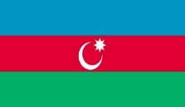

|  |  |  |  |
| --- | --- | --- | --- |
|  |  |  |  |

**“SUPPORT TO STRENGTHENING THE HIGHER EDUCATION SYSTEM IN AZERBAIJAN”**

**Twinning Project** **ENI/2018/395-401**

**AZ/14/ENI/OT/01/17 (AZ/49)**

**This Project is funded by the European Union**

**14 February, 2019**

# Academic recognition of foreign qualifications

<http://www.aic.lv/portal/en/arvalstu-diplomu-atzisana/academic-recognition-of-foreign-qualifications>

# Professional recognition of foreign qualifications

<http://www.aic.lv/portal/en/arvalstu-diplomu-atzisana/professional-recognition-of-foreign-qualifications-in-latvia>

# Data Base on Regulated Professions

<http://www.aic.lv/regdip/?lang=2>