What are the learning outcomes?

Learning outcomes are statements of what a student is expected to know, understand and/or be able to demonstrate after completion of a process of learning
(ECTS Users’ Guide)

This approach is referred to as an outcomes-based approach where learning outcomes are used to express what students should be capable of doing at the end of the process of learning. With the implementation of the Bologna Process, all modules and programmes throughout the participating countries must be expressed using learning outcomes.
What is a purpose of learning outcomes?
The use of learning outcomes as a type of common language for describing qualifications helps to make these qualifications clearer to other institutions, employers and those involved in evaluating qualifications.
The use of learning outcomes when describing programmes and subjects makes it very clear to students what they are expected to achieve by the end of the programme or module. This also assists students in the choice of programmes and in actively participating in student-centred learning.
What are the differences between Programme aim and learning outcomes?
The aim of a programme is a broad general statement of the teaching intention, i.e. it indicates what the lecturer intends to cover in a block of learning.
One of the advantages of learning outcomes is that they are clear statements of what the student is expected to achieve and how he or she is expected to demonstrate that achievement. Thus, learning outcomes are more precise, easier to compose and far clearer than aim.

Why write learning outcome statements?
- Identifying outcomes is an effective way to review your curriculum and content. This leads to a more balanced and well-sequenced curriculum.
- It helps you design appropriate assessment and evaluation tools that accurately reflect the curriculum.
- The learning outcomes help inform everyone as to what new knowledge or skills they are intended to learn.
- Lecturers are able to evaluate the effectiveness of their teaching - have the outcomes been achieved.
- An instructional shift from teaching to learning is facilitated. The focus is on the learner rather than the lecturer.
- Students will know exactly what they are expected to learn, thus avoiding ambiguity.
- Students will know exactly how their learning will be assessed.
- Students begin to take more responsibility for their own learning when they know what they are expected to do and what standard they are expected to achieve.

How to write learning outcomes?
Bloom’s taxonomy is frequently used for writing learning outcomes as it provides a ready-made structure and list of verbs. These verbs are the key to writing learning outcomes.
It is recommended to have a small number of important learning outcomes rather than a large number of superficial ones. There should be 5 – 10 learning outcomes for a programme. Programme learning outcomes describe the essential knowledge, skills and attitudes that it is intended that graduates of the programme will be able to demonstrate.
Learning outcomes must be simply and clearly described and must be capable of being assessed, i.e. they should be written in a way that allows testing of whether or not the student has achieved the outcome.
The following guidelines may be of assistance when writing Learning Outcomes:
When writing programme learning outcomes, it is common practice to use an initial statement like “On completion of this programme, it is expected that the students will be able to…”
- Begin each learning outcome with an active verb, followed by the object of the verb followed by a phrase that gives the context.
- Use only one verb per learning outcome.
- Ensure that the learning outcomes of the subject relate to the overall learning outcomes of the programme.
- The learning outcomes must be observable and measurable.
- Ensure that the learning outcomes are capable of being assessed.
- When writing learning outcomes, bear in mind the timescale within which the outcomes are to be achieved. Ask yourself if it is realistic to achieve the learning outcomes within the time and resources available.
Avoid:
• Vague terms like know, understand, learn, be familiar with, be exposed to, be acquainted with, and be aware of. These terms are associated with teaching objectives rather than learning outcomes.
• Complicated sentences. If necessary, use more than one sentence to ensure clarity.

NOTE:
- When writing learning outcomes for programmes, it is important to ensure that, where applicable, the learning outcomes for professional bodies are incorporated into the programme outcomes – discuss learning outcomes with the representatives of the labour market.
- Before finalising the learning outcomes, ask your colleagues and possibly former students if the learning outcomes make sense to them.

Referring programme learning outcomes with subjects
It is possible to use the mapping to help to get an overview of how the programme learning outcomes are covered within the various subjects offered in the programme. The coverage of each programme learning outcomes within the subjects may be shown in the form of a grid:

Programme Learning Outcome | Subject 1 | Subject 2 | Subject 3 | Subject 4 | Subject 5
Outcome 1 | X |  | X
Outcome 2 |  | X |  | X
Outcome 3 | X |  |  |  | X
Outcome 4 |  | X
Outcome 5 |  |  | X | X | X
Outcome 6 | X

Reference points for Programme Learning Outcomes
Programme Learning outcomes should correlate with external reference documents. During the development of programme learning outcomes Higher Education Institutions must have consultations with labour market representatives.

ANNEXES

ANNEX 1. CHECKLIST FOR WRITING LEARNING OUTCOMES
- Have I focussed on outcomes not processes, i.e. have I focussed on what the students are able to demonstrate rather than on what I have done in my teaching?
- Have I begun each outcome with an active verb?
- Have I used only one active verb per learning outcome?
- Have I avoided terms like know, understand, learn, be familiar with, be exposed to, be acquainted with, and be aware of?
- Are my outcomes observable and measurable?
- Are my outcomes capable of being assessed?
- Have I included learning outcomes across the range of levels of Bloom’s Taxonomy?
- Do all the outcomes fit within the aims and content of the programme?
- Have I the recommended number of outcomes (maximum of nine per programme)?
- Is it realistic to achieve the learning outcomes within the time and resources available?

ANNEX 2. EXAMPLES OF PROGRAMME LEARNING OUTCOMES

Example 1. Programme Learning Outcomes for Bachelor degree in Education
On successful completion of this programme, students should be able to:
- Recognise and apply the basic principles of classroom management and discipline.
- Identify the key characteristics of excellent teaching in science.
- Develop comprehensive portfolios of lesson plans that are relevant to the science curricula in schools.
- Evaluate the various theories of Teaching and Learning and apply these theories to assist in the creation of effective and inspiring science lessons.
- Critically evaluate the effectiveness of their teaching of science in the second-level school system.
- Display a willingness to co-operate with members of the teaching staff in their assigned school.
- Foster an interest in science and a sense of enthusiasm for science subjects in their pupils.
- Synthesise the key components of laboratory organisation and management and perform laboratory work in a safe and efficient manner.
- Communicate effectively with the school community and with society at large in the area of science education.

Example 2. Programme Learning Outcomes for Master Degree in Education
On successful completion of this programme, students should be able to:
- Behave in a professional manner with members of the teaching placement school communities and with all other professionals in the context of the Teaching Council’s Code of Practice.
- Critically evaluate the various theories of Teaching and Learning, including curriculum design, and apply these theories to assist in teaching effective and inspiring lessons in the classroom.
- Select from complex and advanced skills in the field of Education and develop new skills, including those of pedagogy and assessment practices, to a high level.
- Synthesise the key components of some areas of current research in the field of Education and carry out a small scale research project to a professional standard.
- Develop comprehensive portfolios that chart their progress as reflective practitioners carrying out research in the areas of professional tasks and experiences in their placements schools and at university.
- Discuss topics in the field of Education to demonstrate a critical awareness of current problems and new insights informed by development in this area.
- Appraise the role of the teacher in the modern classroom to help manage their own learning and professional development.
- Foster an interest in and enthusiasm for their specialist subject among their pupils. Display a willingness to participate in all aspects of the programme in a spirit of co-operation and enthusiasm.
- Communicate effectively key aspects of knowledge and understanding in the field of Education to specialist and non-specialist audiences.
Example 3. Programme Learning Outcomes for Bachelor Degree in Engineering
On successful completion of this programme, students should be able to:
- Derive and apply solutions from knowledge of sciences, engineering sciences, technology and mathematics.
- Identify, formulate, analyse and solve engineering problems.
- Design a system, component or process to meet specified needs and to design and conduct experiments to analyse and interpret data.
- Work effectively as an individual, in teams and in multi-disciplinary settings together with the capacity to undertake lifelong learning.
- Communicate effectively with the engineering community and with society at large.

Example 4. Programme learning outcomes for a Master degree in Computer science
On completion of this programme, it is expected that the students will be able to:
- Perform problem solving in academic and industrial environments.
- Use, manipulate and create large computational systems.
- Work effectively as a team member.
- Organise and pursue a scientific or industrial research project.
- Write theses and reports to a professional standard, equivalent in presentational qualities to that of publishable papers.
- Prepare and present seminars to a professional standard.
- Perform independent and efficient time management.
- Use a full range of IT skills and display a mature computer literacy.

ANNEX 3. PRACTICAL TOOLS OF BLOOM’S TAXONOMY FOR WRITING LEARNING OUTCOMES

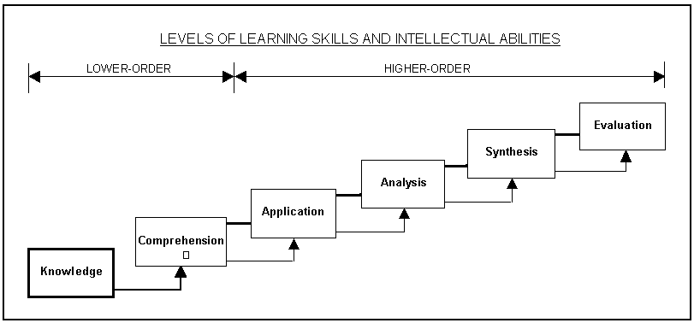
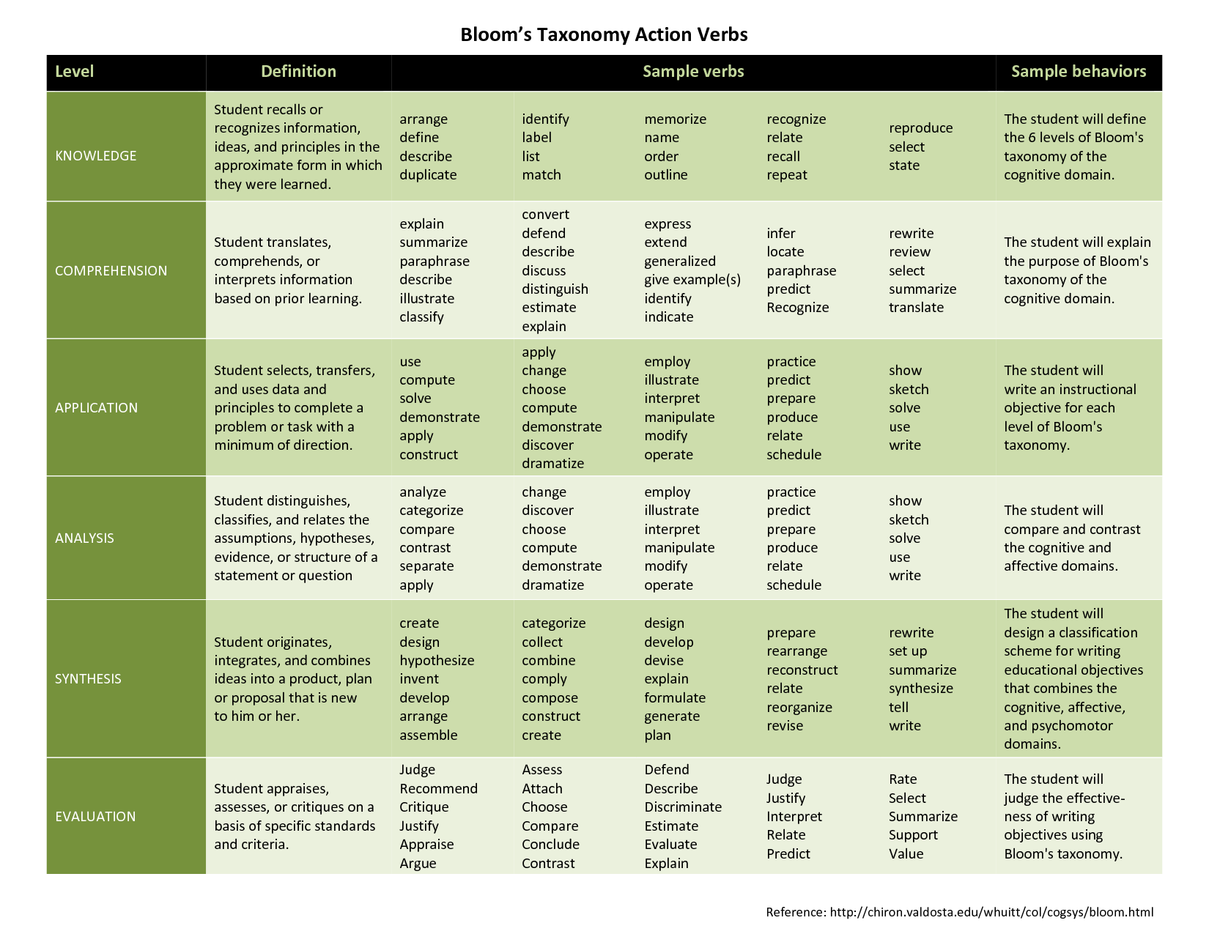

ANNEX 4. LIST OF IMPORTANT LINKS

- Kenney D., Learning Outcomes Book https://cora.ucc.ie/bitstream/handle/10468/1613/A%20Learning%20Outcomes%20Book%20D%20Kennedy.pdf?sequence=1

Video on How to Write Learning Objectives Using Bloom's Taxonomy https://www.youtube.com/watch?v=4DgkLV9h69Q

European Qualification Framework

https://ec.europa.eu/ploteus/en/content/descriptors-page

Azerbaijan National Qualification Framework

http://e-qanun.az/framework/39622

https://cora.ucc.ie/bitstream/handle/10468/1613/A%20Learning%20Outcomes%20Book%20D%20Kennedy.pdf?sequence=1 ; https://www.youtube.com/watch?v=4DgkLV9h69Q

