Annex 1.1
ELABORATING A LEARNRING AGREEMENT: example 1
Bachelor program in Physics
A student from the Baku State University leaves on the 3rd semester for a mobility to the University of Nantes in France.
The subjects (courses) of the 3rd semester of the bachelor program in physics in Baku State University are (cf. Annex 1.1):
- Electric and magnetism (9 ECTS)
- Analytical geometry (4 ECTS)
- Differential and integral equations (4 ECTS)
- Informatics (5 ECTS)
- Astronomy (4 ECTS)
- General chemistry. Chemistry of elements (4 ECTS)

Total ECTS credits: 30.
Which related courses (subjects) can be found in the study plan of Nantes University (cf. annex 1.2) ? Note that the student can choose any course of the 1st, 3rd or 5th semester.
To check the equivalency between the courses (subjects) it is recommended to check the related learning outcomes.
- Semester 3 UE 5 : electromagnetism (5 ECTS)
- Semester 5 UE 4 : electromagnetism (3 ECTS)
These 2 courses match perfectly; 10 ECTS instead of 9 ECTS but it is not a problem.
- Semester 3 : UE 6: mathematic tools (4 ECTS)
- Semester 5 : UE 2: mathematic tools (5 ECTS)
Also in this case the number of credits is not exactly the same, but the difference is not significant.

- Semester 1 UE 4 : Informatics (5 ECTS) : no problem!

- Semester 4 UE 8 : astrolophysics and planetology : the “same” course exists but the student cannot attend it because it is taught only the next semester.. Two possibilities : choose the UE 7 of semester 1 : universe sciences (3 ECTS) ; it is an introductive course, so the level is likely to be lower than in Baku, or replace by another course, for instance semester 5 UE 3 : Quantum mechanics (5 ECTS)

- Semester 1 UE 3 :chemistry : atom, bonds, molecule (5 ECTS).

Total ECTS credits : 30 if the student chooses UE universe sciences, 32 in the other case (if he chooses UE quantum mechanics). It is recommended to choose the solution which is closer to 30 ECTS but a small gap may be accepted.

Conclusion : the contents of the courses are the same in the two study plans. The only problem is a difference of level for one or two courses. So there should not be problem for the sending University to validate the whole 3rd semester. In this case, each subject (course) of the semester could be validated separately.

Figure 1.1 : Courses of the 3rd semester in Baku State University

3rd SEMESTER
Subjects of profession-training of specialty
IPF-B03 Electrical and magnetism | 9 | 165 | 105 | 270 | written | 8
IPF-B10 - Analytical Geometry | 4 | 75 | 45 | 120 | written | 5
IPF-B11 -Differential and Integral Equations | 4 | 60 | 60 | 120 | written | 5
IPF-B13-Informatics | 5 | 60 | 60 | 120 | written | 5
IPF-B15 - Astronomy | 4 | 150 | 90 | 240 | written | 5
Selected subjects
I block, İPFS-B03 | 4 | 60 | 60 | 120 | written | 6
1 General chemistry
2. Chemistry of elements
Semester total | 30 | 570 | 420 | 990

Figure 1.2 : the study plan for bachelor program in physics at the French university of Nantes

SEMESTER 1
- UE 1 : English ; 16h 2 ECTS credits
- UE 2 : Methodology, digital tools ; 20h 2 ECTS credits
- UE 3 : Chemistry : atom, bonds, molecule ; 36h 5 ECTS credits
- UE 4 : Informatics; 36h 5 ECTS credits
- UE 5 : Mathematics ; 48h 5 ECTS credits
- UE 6 :Calculating tools for sciences ; 18h 3 ECTS credits
- UE 7 : Universe Sciences ; 18h 3 ECTS Credits
- UE 8 : Physics : electricity, material point mecanichs, conferences; 36h 5ECTS credits
SEMESTER 2
- Chemistry –Physics Group (27 ECTS credits)
- UE 1 :english ; 16h 3 ECTS credits
- UE 2 :thermochemistry ; 36 h 4 ECTS credits
- UE 3 :organic and inorganic chemistry ; 36h 4 ECTS credits
- UE 4 : work practices in laboratory (chemistry) ; 36h 4 ECTS credits
- UE 5 : mathematics tools ; 36h 4 ECTS credits
- UE 6 : introduction to thermodynamics ; 36h 4 ECTS credits
- UE 7 :experimental physics 1 ; 19 h 2 ECTS credits
- UE 8 : mechanics 1; 18h 2 ECTS credits
- History of sciences Group (3 ECTS credits).
To choose one among :
- UE 1 :matter and energy ; 20h 3 ECTS credits
- UE 2 : knowledge and innovation ; 20h 3 ECTS credits
- UE 3 :different ways of scientist reasoning ; 20h 3 ECTS credits
SEMESTER 3
- UE 1 : english ; 16 h 2 ECTS credits
- UE 2 : electromagnetism ; 40 h 5 ECTS credits
- UE 3 : general mechanics 1, statics of solids and systems ; 20h 2 ECTS credits
- UE 4 :geometric and wave optics ; 40h 5 ECTS credits
- UE 5: general mechanics 2, dynamics of solids and systems ; 40 h 5 ECTS credits
- UE 6: mathematics tools; 40h 4 ECTS credits
- UE 7: linear algebra for PC ; 40h 4 ECTS credits
- UE 8:thermodynamics 2 ; 20h 2 ECTS credits
- UE 9 : professional project in physics ; 12h 1ECTS credit
SEMESTER 4
1. Core courses (25 ECTS credits)
- UE 1 : english scientific project ; 16h 2 ECTS credits
- UE 2 : electromagnetism 2 ; 40h 5 ECTS credits
- UE 3 : modern physics 1 ; 40 h 5 ECTS credits
- UE 4 : experimental physics 2 ; 20h 1 ECTS credit
- UE 5: electronics ; 40h 5 ECTS credits
- UE 6: modelisation for physics ; 20h 2ECTS credits
- UE 7: mechanics of deformable environments ; 40h 5 ECTS
2. Additional courses (4 ECTS)
- UE 8 : astrophysics, planetology ; 40h 4 ECTS credits
or
- UE 9 : renewable energies ; 40h 4 ECTS credits
3. Optional courses (16 h 1 ECTS)
To choose among: Music and sciences. Volunteering. Sociology of research laboratories. Preparation of scientific documentation. From anticancer drugs to not-stick coatings: the results of observation. Infinitely small imagery technics. Sport. Arts and sciences. Cryptography and arithmetic. Digital creation. Webpage creation. Climate yesterday, today and tomorrow. Science, culture, society. Scientific and technologic debates across the centuries.

SEMESTER 5
- UE 1 : English for scientific communication ; 16 h 3 ECTS credits
- UE 2 : Mathematic tools ;48h 5 ECTS credits
- UE 3 : Quantum mechanics ; 50 h 5 ECTS credits
- UE 4 : Electromagnetism 3 ; 24h 3ECTS credits
- UE 5 : Modern physics 2 ; 40h 5ECTS credits
- UE 6 : Subatomic physics ; 40h 5 ECTS credits
- UE 7: Analytic mechanics ; 18h 2 ECTS credits
- UE 8: Professional project in physics ; 16h 2 ECTS
SEMESTER 6
- UE 1 : English for scientific communication ; 16 h 2 ECTS credits
- UE 2 : Thermodynamics 3 ; 42 h 5ECTS credits
- UE 3 : Solid state physics ;42h 5 ECTS credits
- UE 4: Modelization for physics 3 ; 28h 3 ECTS
- UE 5: Mecanic, acoustic, electromagnetic waves ; 48h 6 ECTS credits
- UE 6: Experimental physics 3 ; 42 h 6 ECTS credits
- Internship : 3 ECTS credits

Annex 1.2
ELABORATING A LEARNRING AGREEMENT : example 2
Bachelor in Sales and Marketing
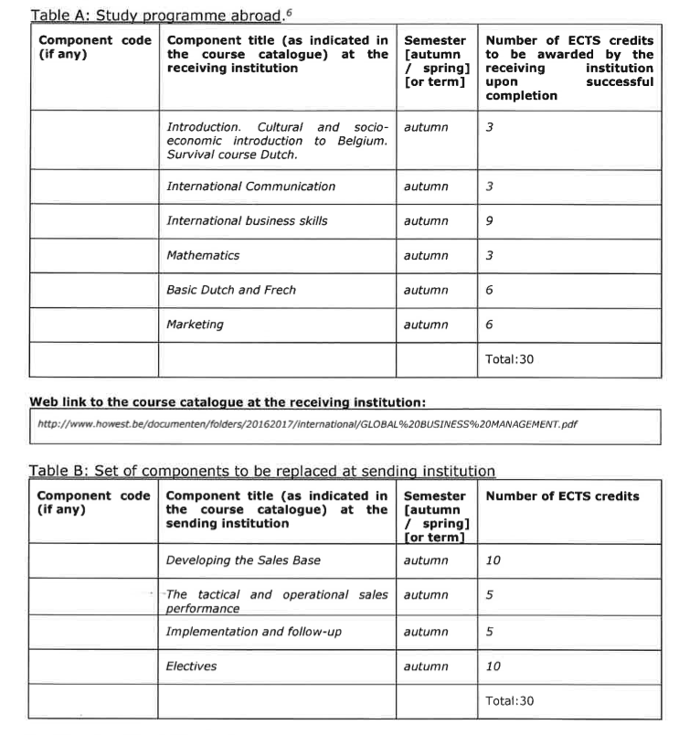

This second example is interesting as far as it seems very different from the previous one, and apparently it could be considered as not very satisfactory for two reasons:
- First, there is not a clear equivalency established between the components of the sending and receiving institutions: in fact, 4 components of the sending university needs 6 components at the receiving university to be recognized.
- Second, the tittle of the components seems very different, and it is not clear on the base of which criteria equivalency has been established.

However, this learning agreement is quite correct and acceptable. Why?
- The total of credits is the same, which legitimates the recognition of the whole semester without focusing too much attention on each component.
- The component “electives” allows more flexibility; the first component “Introduction. Cultural…” (3 ECTS) and the component “Basic Dutch and French “(6 ECTS) can easily be recognized as elective courses. They represent 9 credits respect to 10 credits, which is easily acceptable. Otherwise, a course about the culture and the socio- economic situation in Belgium is specific to the receiving university and is not taught in the sending university. Hence, there is an added value, and in this case 9+ =10!
- The learning outcomes of “International Communication” and “International Business Skills” are likely to be at least 75% similar to the learning outcomes of ‘Developing the sales base” and “The tactical and operational sales performance”. We have 12 credits to correspond to 15 credits. The gap is more important, but tolerance is a good virtue.
- It seems that the component “mathematics” (3 ECTS) does not match any component of the sending institution. But mathematics can be considered as a transversal tool which is useful for accounting competences that a seller needs.
- The component “implementation and follow-up (5 ECTS)” appears isolated, and no component of the receiving institution matches. Why the recognition has been accepted? Probably because there was no similar or close course available during the semester of mobility, but the person who is supervising the mobility has considered it was a pity to refuse this learning agreement and make the mobility impossible, while only 8% of the study program did not match.

Conclusion:
The second example shows more flexibility and tolerance than the first one, but remember that in the context of globalization, mobility is a priority, and the famous “ivory tower” could be appreciated by the French writer Montaigne who was living in the XVIth century, but is no longer appropriate in 2020.

U.E = Unité d’Enseignement (Teaching Unit) is the equivalent of « course ».

