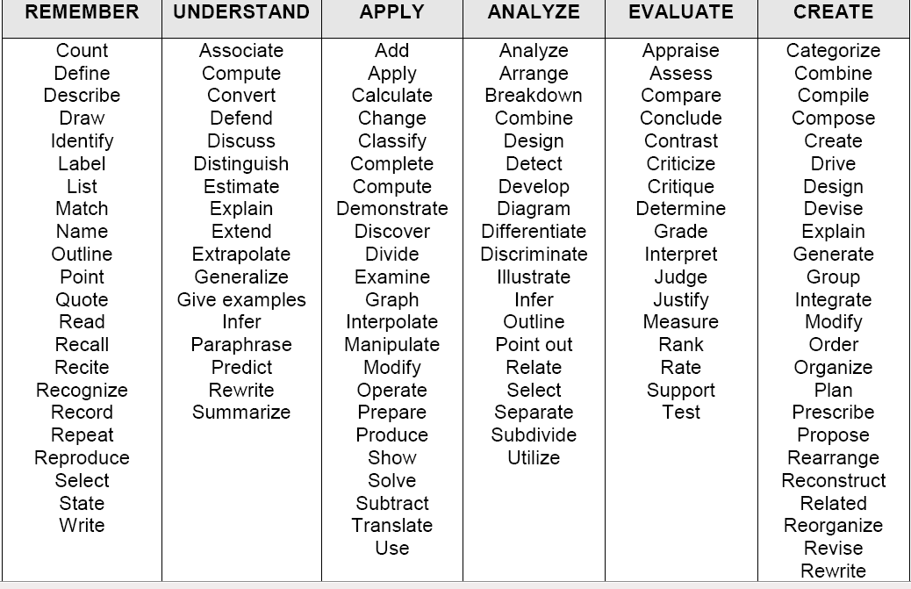

BLOOMS taxonomy: the words associated with different categories of learning