Support to strengthening the higher education system in Azerbaijan



Twinning project ENI/2018/395-401

Full name of experts



**Mr. Mourad Attarça, France** Signature

**Ms. Ilva Grigoryeva, Latvia** Signature



**Ms. Ilona Kazlauskaite, Lithuania** Signature

**Guidelines for student-centred learning at study programme**

“ *I’m always ready to learn although I do not always like being taught”* (*Winston Churchill)*

“*Learning results from what the student does and thinks, and only from what the student does and thinks. The teacher can advance learning only by influencing what the student does to learn*” (Herbert Simon, Nobel Prize 1978)

“Student-Centred Learning (SCL) is a process of qualitative transformation for students and other learners in a learning environment, aimed at enhancing their autonomy and critical ability through an outcome based approach” (ECTS Users’ Guide 2015).

The SCL concept can be summarised into the following elements:

* Reliance on active rather than passive learning;
* Emphasis on critical and analytical learning and understanding;
* Increased responsibility and accountability on the part of the student;
* Increased autonomy of the student;
* A reflective approach to the learning and teaching process on the part of both the student and the teacher.”

1. **The principles of a student-centred learning (SCL)**

The main principles of student-centred learning are:

* The learner has full responsibility for his/her learning
* Involvement and participation are necessary for learning
* The relationship between learners and teachers is more equal, promoting growth, development
* The teacher becomes a facilitator and resource person
* The learner experiences ‘confluence’ in his/her education
* The learner sees himself/herself differently as a result of the learning experience

**Definition of Student-centred learning**

|  |
| --- |
| Student-centred learning (SCL) remains a debated concept with no one clear definition available, since multiple interpretations co-exist which exclude each other.  “Student-Centred Learning represents both a mindset and a culture within a given higher education institution and is a learning approach which is broadly related to, and supported by, constructivist theories of learning. It is characterised by innovative methods of teaching which aim to promote learning in communication with teachers and other learners and which take students seriously as active participants in their own learning, fostering transferable skills such as problem-solving, critical thinking and reflective thinking.” *(Student-Centered Learning Toolkit, publication published on the project “Time for a New Paradigm in Education: Student Centered Learning”, funded with support from the European Commission)* |

1. **Process of designing a student-centred study programme**

The process for designing a student-centred study programme follows several stages:

1. Definition of academic and professional profiles
2. Identification of resources
3. Programme design: definition of learning outcomes / competences
4. construction of curricula: content and structure + balanced ECTS credit allocation
5. Selection of types of assessment
6. Selection of teaching and learning approaches
7. Evaluation and improvement (on the basis of feedback and feed-forward)

**A student-centred approach:**

- encourages thought about the types of student for whom a programme is being designed

- reminds designers of possible resource requirements for different students

- focuses attention on the competences to be acquired by students

- includes student representative(s) in a designing or improvement of study programme

The process for designing a student-centred study programme is based on identifying the main competences that the learner should have at the end of the learning process (a course or a programme): competences should be aligned with the market needs, using some pedagogical methods and tools in which learner (student) has an active position (in order to develop skills and attitudes and not only knowledge)  and using appropriate assessment methods that are adapted to the learning process. The process may be different depending on whether we are creating a new programme or adapting an existing programme. On both case, the process should be taylored as a process of continuous improvement:

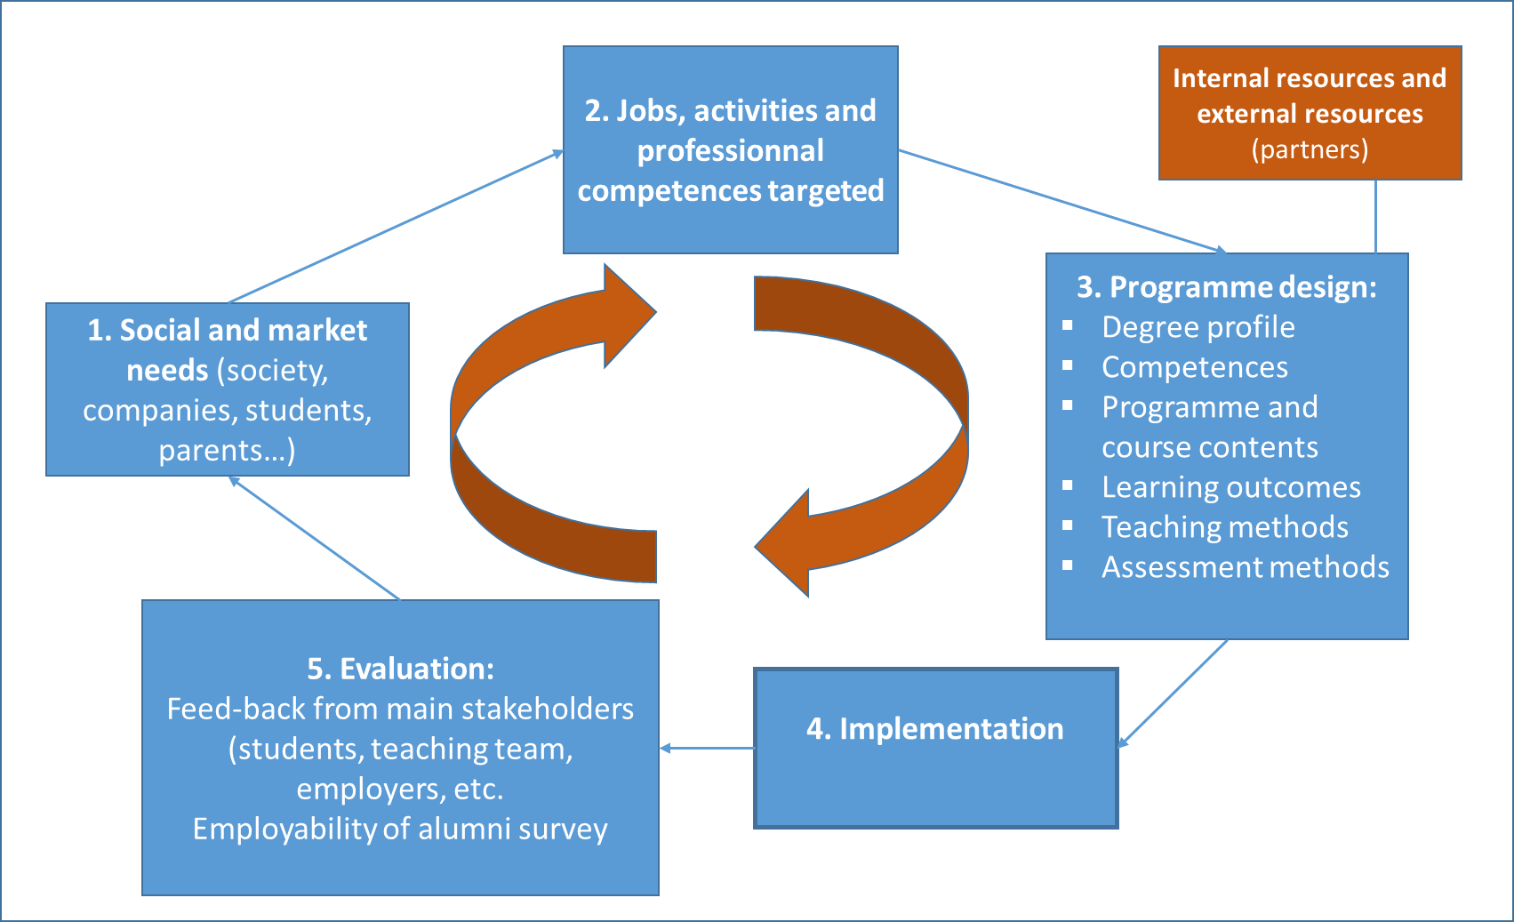

*See more at: “Guideline for self-assessing the competence-orientedness and student-centeredness of a study programme”, prepared during the previous mission*

1. **The quality of the student-centred study programme**

**Study programme level**

The study programme is recognised to meet competences that are aligned with the job market needs. The competences are defined in connection with external stakeholders: companies, business associations, union trades, other social partners etc.

The study programme clearly indicates what are the competences that the students should have at the end of the learning process and how those competences will be acquired.

Study Programme Committee, which is responsible for designing of the student-centred programme shall consist of representatives of teachers, students and employers.

Improvement and renewal of current study programme is usually performed by Study Programme Committees, departments which implement the programme and programme teachers, also may be initiated by the **students** (presenting well-argued suggestions), University academic units, Faculty Councils, and social partners.

**Course level**

The curriculum gives students a clear indication of what is expected of them in terms of learning outcomes, performance, conditions and standard. Also, if appropriate, workplace and off-the-job training and assessment responsibilities should be identified.

Course delivery is flexible, and students can exercise initiative in the learning process. Student-teacher collaboration in teaching and learning should be encouraged and supported, as it creates, maintains and develops new and continuous learning experiences. The culture of cooperation **requires both actors to prepare and engage.**

Assessment of student’ performance should be clear defined, presented and agreed with the students at the beginning of course.

Systematic approach to the assessment of student achievements:

* Coherence of learning outcomes, learning activities and assessment
* Student-teacher collaboration
* Consistent use of a assessment (scoring) scale
* Planning of the Achievement Assessment Process
* Student engagement
* Support for the teacher (Competence Development)

**Feedback system**

Students are important stakeholders in the quality monitoring and assessment process, and it is important to obtain their views.

Feedback **from students** has two main functions:

* internal information to guide improvement of study programme;
* external information for potential students and other stakeholders

Feedback **for students**:

* Feedback helps to get information for current and potential students about the situation regarding study quality
* Feedback for students is very important part in education system. They always are interested in and looking forward to hear identified areas for action and what kind of improvements will be carried out

**Feadback for teachers:**

* The power of feedback for teachers is information about what is happening in their courses and their classroom;
* Feedback helps the teacher to identify and meet the needs of the students;
* Feedback assists the teacher in improving and further developing their teaching.